Vertical Electrophoresis Tank

Vertical Electrophoresis Tank

Application:

Vertical electrophoresis is used for separation, purification and preparation of nucleic acid and protein samples in life science research.

Features:

Application:

Vertical electrophoresis is used for separation, purification and preparation of nucleic acid and protein samples in life science research.

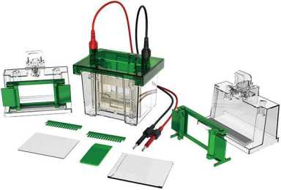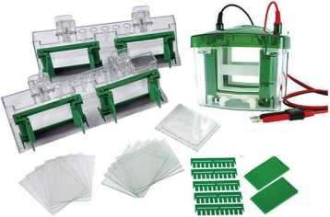

* High-transparency polycarbonate injection molding, durable and easy to observe.
* The integrated design of the glass cushion strip ensures that there is no leakage of glue.
* The special glue making rack makes the glue making operation simple and reliable.
* Open the cover and cut off the power to ensure the safety of the experiment.
* The upper cover limit function ensures that the polarity of the electrode will not be connected incorrectly.
* The power-off function of opening the lid ensures the safety of the experiment.
* It can make double-board glue at the same time, with clear strips.
* 99.99% high-purity platinum electrode, the best conductivity, strong corrosion resistance.
* Recommended power supply: BEP-3001, BEP-6001, BEP-600D.

Technical Parameters:

Features:

* High-transparency polycarbonate injection molding, durable and easy to observe.
* The integrated design of the glass cushion strip ensures that there is no leakage of glue.
* The special glue making rack makes the glue making operation simple and reliable.
* Open the cover and cut off the power to ensure the safety of the experiment.
* The upper cover limit function ensures that the polarity of the electrode will not be connected incorrectly.
* The power-off function of opening the lid ensures the safety of the experiment.
* It can make double-board glue at the same time, with clear strips.
* 99.99% high-purity platinum electrode, the best conductivity, strong corrosion resistance.
* Recommended power supply: BEP-3001, BEP-6001, BEP-600D

Technical Parameters:

|  |  |
| --- | --- |
| Model BK-VET01 | |
| Glass Tray (W*L) | Thick type: 101*83mm, thin type: 101*73mm |
| Gel Trays(W*L) | Hand glue: 83*73mm, precast glue: 86*68mm |
| Comb Thickness | Standard 1.0mm, optional 0.75&1.5mm |
| Comb Throughput | 10,15 samples |
| Amount of Gel | 1~2 pcs |
| NO. of Samples | 10~30pcs |
| Buffer Volume | 700ml |
| Standard Accessories | Body tank *1, Cap*1, Electrode core*1 set, Gel casting base*2, Gel frame*2,  Single glue baffle* 1, Gel shovel* 1, Glass plates*5 pairs, 1.0mm thicknesslO wells comb*2,  1.0mm thickness 15 wells comb*2 |
| External Size (L*W*H) | 150*120*130mm |
| Package Size(L*W*H) | 400*350*300mm |
| Gross Weight | 2.7kg |

|  |  |
| --- | --- |
| Model BK-VET02 | |
| Glass Tray (W*L) | Thick type: 101*83mm, thin type: 101*73mm |
| Gel Trays(W*L) | Hand glue: 83*73mm, precast glue: 86*68mm |
| Comb Thickness | Standard 1.0mm, optional 0.75&1.5mm |
| Comb Throughput | 10 samples |
| Amount of Gel | 1~4 pcs |
| NO. of Samples | 10~40pcs |
| Buffer Volume | 1000ml |
| Standard Accessories | Body tank *1, Cap*1, Electrode core*1 set, Gel casting base*2, Gel frame*4,  Single glue baffle*1, Gel shovel*1, Glass plates*5 pairs, 1.0mm thicknesslO wells comb*5 |
| External Size (L*W*H) | 180*130*130mm |
| Package Size(L*W*H) | 400*350*300mm |
| Gross Weight | 3.9kg |

249

250